1. Access to VM as we tried with IP address and remote connection using credentials you gave us. Please, can you send us some additional info regarding connection

Below is message which we get:

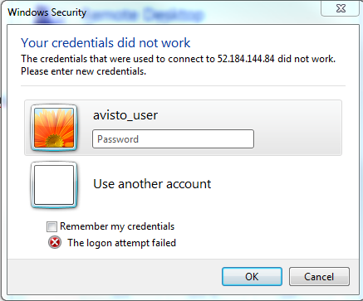

Some additional connection info would not hurt

1. As we've seen VM contains VS 2017 and SQL Management Studio for Azure. Is every user of that VM allowed to use them or some additional installations are needed
2. As there is a script for start and shut down of VM which starts that VM every day at 9.00 and shuts it down at given time, how is VM used by developers when it's shut down

Ja sada kao hocu da pitam nesto da proverim koliko nesto znam